In April the CHAP (Chronic Hypertension and Pregnancy) Trial was published in the New England Journal of Medicine. Below is a summary of the results of this trial in addition to practice implementation recommendations and links to the CHAP Trial and SMFM/ACOG endorsement statements. Based on this evidence there is support for immediate practice change to reflect these recommendations.

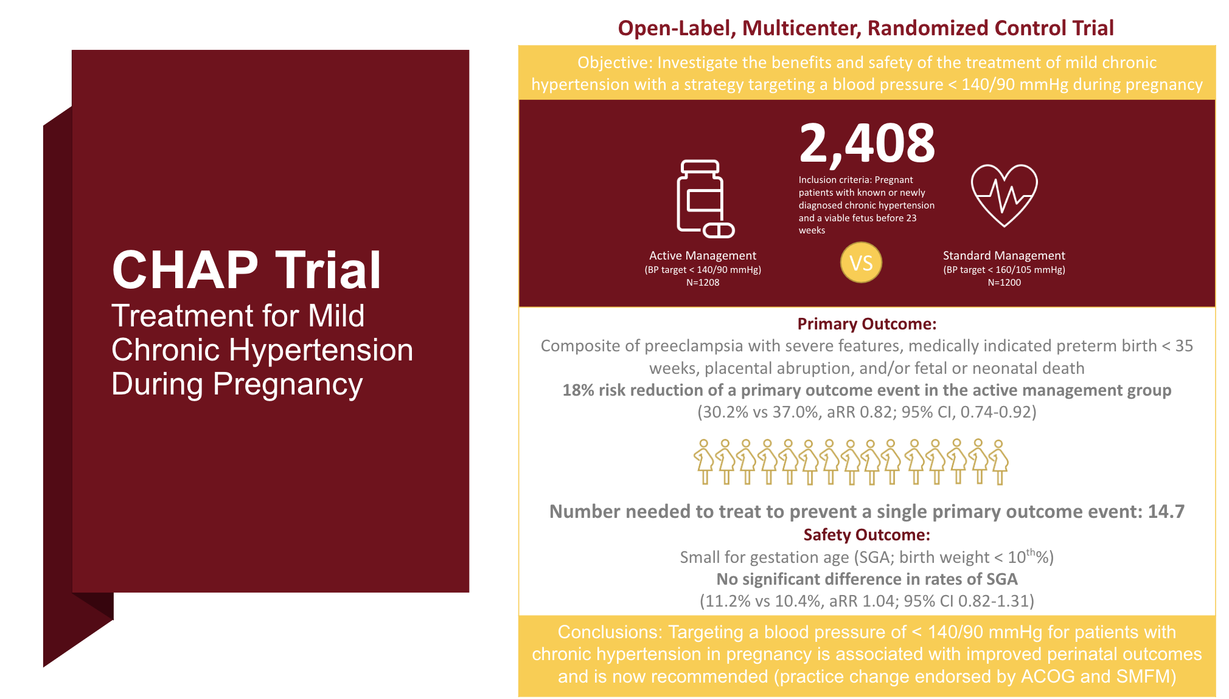

Practice Implementation
- Screen all patients at the beginning of pregnancy for chronic hypertension
- All patients with chronic hypertension should have a blood pressure cuff and should keep a blood pressure log
- Recommend initiation of pharmacologic treatment for patients with mild chronic hypertension prior to 20 weeks with a BP goal < 140/90 mmHg
- Patients with chronic hypertension currently on medications should continue antihypertensive therapy during pregnancy or change to a regimen compatible with pregnancy to achieve this treatment goal
  - First line medications: Labetalol, Nifedipine
- Acute, severe, or persistent elevations in blood pressure in the second half of pregnancy warrants further evaluation for the development of superimposed preeclampsia and was required in the CHAP trial before medication dose escalation took place beyond 20 weeks’ gestation

References
CHAP Trial
Tita AT, Szychowski JM, Boggess K, Dugoff L, Sibai B, Lawrence K, et al. Treatment for mild chronic hypertension during pregnancy. Chronic Hypertension and Pregnancy (CHAP) Trial Consortium. N Engl J Med. Published online April 2, 2022. doi: 10.1056/NEJMoa2201295

ACOG Statement
https://www.acog.org/clinical/clinical-guidance/practice-advisory/articles/2022/04/clinical-guidance-for-the-integration-of-the-findings-of-the-chronic-hypertension-and-pregnancy-chap-study

SMFM Statement
https://els-jbs-prod-cdn.jbs.elsevierhealth.com/pb/assets/raw/Health%20Advance/journals/ymob/SMFM_Statement_CHAP_draft_April_2022.pdf

